LINEAR REGRESSION

**Regression Analysis** is a form of **predictive modelling technique** which investigates a **relationship** between a **dependent** and **independent variable**.

Uses of regression analysis:

* Determining the strength of predictors
* Forecasting an effect
* Trend forecasting

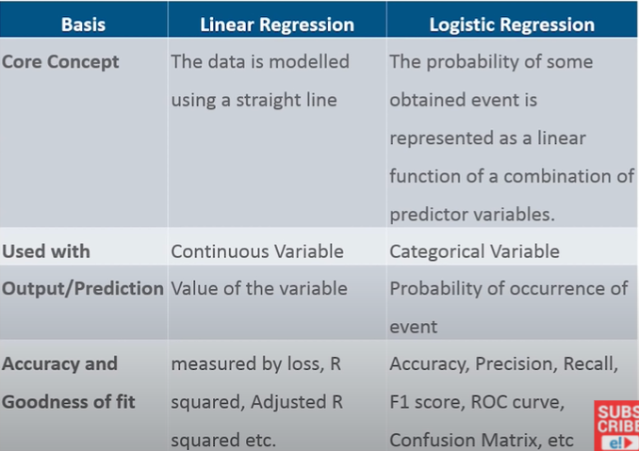

Where is Linear Regression used

* Evaluating trends and sales estimate
* Analysing the impact of price changes
* Assessment of risk in financial services and insurance domain